****Name: _______________________________

Full Test (Sections 1 and 2)

Total Time: 58 minutes

Total Marks: 50 marks

Student Result ________/ 50

**MATHEMATICS METHODS Unit 3**

**TEST 2 -2021**

**Exponential function,**

**Calculus of trigonometric functions,**

**Discrete random variables**

**Calculator Free Section**

Time: 23 minutes

Total Marks: 20 marks

Resources allowed: SCSA Formula Sheet

**Instructions to candidates**

Show all your working clearly. Your working should be in sufficient detail to allow your answers to be checked readily and for marks to be awarded for reasoning. Incorrect answers given without supporting reasoning cannot be allocated any marks**. For any question or part question worth more than two marks, valid working or justification is required to receive full marks.** If you repeat any question, ensure that you cancel the answer you do not wish to have marked.

|  |  |
| --- | --- |
| **Question 1** | **[2, 2 = 4 marks]** |

Determine given that

(a) $f\left(x\right)=e^{sin3x}$

(b) $f\left(x\right)=\frac{x}{e^{3x} + 5}$ do not simplify your answer.

|  |  |
| --- | --- |
| **Question 2** | **[2 marks]** |

Verify that the table below describes a probability distribution function with reasons.

|  |  |  |  |  |  |
| --- | --- | --- | --- | --- | --- |
|  |  |  |  |  |  |
|  |  |  |  |  |  |

|  |  |
| --- | --- |
| **Question 3** | **[2, 3, 2 = 7 marks]** |

(a) Determine the following indefinite integrals.

(i) 

(ii) 

(b) Evaluate the following definite integral.

$$\int_{\frac{π}{4}}^{\frac{π}{6}}{\cos^{-2}}x dx$$

|  |  |
| --- | --- |
| **Question 4** | **[2 marks]** |

Determine the following. 

|  |  |
| --- | --- |
| **Question 5** | **[2, 3 = 5 marks]** |

The graph of $y=f(x)$ is shown below, where $f\left(x\right)=e^{x}(x^{2}-3)$.

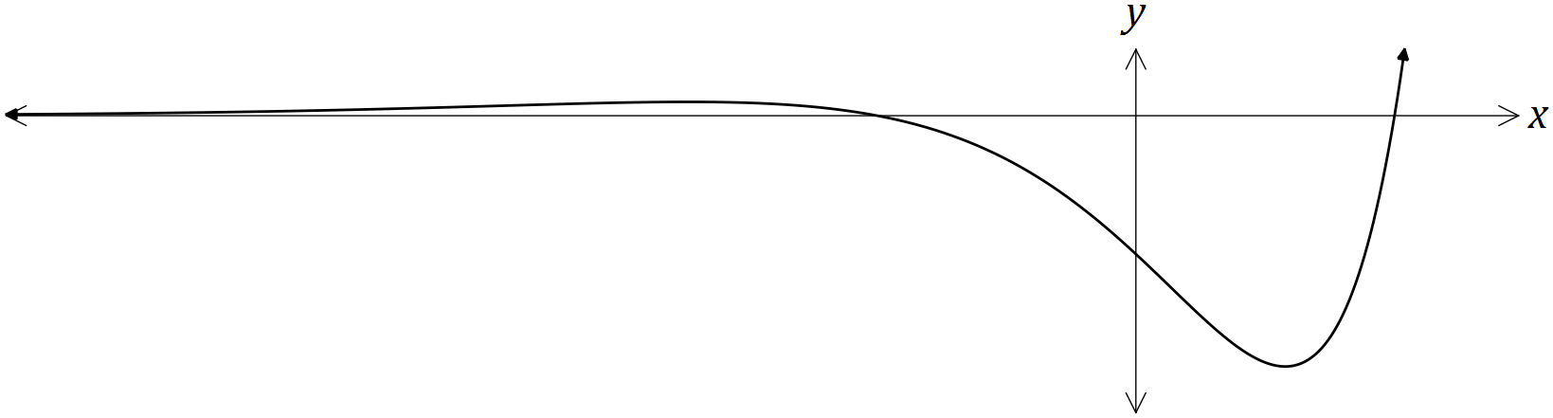

(a) Determine $f^{'}\left(x\right)$, the equation of the gradient function.

(b) Determine the $x$-coordinate only, of all stationary points of $f(x)$.

 Name: ______________________________

**MATHEMATICS METHODS Unit 3**

**TEST 2 -2021**

**Exponential function,**

**Calculus of trigonometric functions,**

**Discrete random variables**

**Calculator Assumed Section**

Time: 35 minutes

Total Marks: 30 marks

Resources allowed: SCSA Formula Sheet

1 A4 (both side) student notes

CAS calculator

**Instructions to candidates**

Show all your working clearly. Your working should be in sufficient detail to allow your answers to be checked readily and for marks to be awarded for reasoning. Incorrect answers given without supporting reasoning cannot be allocated any marks**. For any question or part question worth more than two marks, valid working or justification is required to receive full marks.** If you repeat any question, ensure that you cancel the answer you do not wish to have marked.

|  |  |
| --- | --- |
| **Question 6** | **[2, 2, 3, 1, 2, 1, 1 = 12 marks]** |

Newton’s Rule of cooling states that the rate of change of the temperature of a particle is proportional to the difference between the temperature of the particle and the constant temperature of the surrounding medium. The temperature, T° C, of a particle when placed in a medium with constant temperature of A° C can be modelled by the equation

T = T0e-kt + A

Where t is the time in minutes and T0 is a constant.

A metal ball has been heated to a temperature of 200°C and is placed into a room that is maintained at a constant temperature of 30°C. After 5 minutes, the temperature of the ball has been dropped to 150°C.

(a) State the value of A and hence show that the value of T0 = 170.

(b) Calculate the value of k correct to 4 decimal places.

(c) Using the values found above, state the equation for this model and sketch its graph

<EFOFEX>
id:fxd{a83587f1-87cf-4b28-9483-51194305c40c}

FXData:
</EFOFEX>

(d) Determine the temperature of the rod, correct to 1 decimal place, after 15 minutes.

(e) Calculate the rate of change in temperature, correct to 1 decimal place, at this time.

(f) Determine how long it will take for the temperature of the ball to reach 40°C. Give your answer to 2 decimal places.

(g) Justify why that the metal ball would never reach 10°C if left in the room.

|  |  |
| --- | --- |
| **Question 7** | **[1, 3, 1, 3 = 8 marks]** |

The temperature on a particular day can be modelled by the function

$T(t)=-3\cos\left(\frac{πt}{9}\right)+18$, $0≤t≤18$

Where $t$ is the time in hours after 5.00 am and $T$ is the temperature in degrees Celsius. For the remaining 6 hours of the 24-hour period, the temperature remains constant.

(a) Calculate the temperature at 8.00 am.

(b) At what time(s) of the day is the temperature 20°C? give your answer correct to the nearest minute.

(c) Find $\frac{dT}{dt}$

(d) What is the rate of change of temperature at the time(s) found in part (b), correct to two decimal places?

|  |  |
| --- | --- |
| **Question 8** | **[3 marks]** |

The random variable $X$ has mean 40 and standard deviation 3. The random variable

$Y=aX+b.$ Determine $a$ and $b$, where $a, b>0$, if the mean and standard deviation of $Y$ are 110 and 6 respectively.

|  |  |
| --- | --- |
| **Question 9** | **[2, 1, 2, 2 = 7 marks]** |

It is known that 52% of the population participates in sport on a regular basis. Five random individuals are interviewed and asked whether they participate in sport on a regular basis. Let $X$ be the number of people who regularly participate in sport.

(a) Complete the probability distribution table for $X$, correct to 4 decimal places.

|  |  |  |  |  |  |  |
| --- | --- | --- | --- | --- | --- | --- |
| $$x$$ | $$0$$ | $$1$$ | $$2$$ | $$3$$ | $$4$$ | $$5$$ |
| $$P(X=x)$$ | 0.0255 | 0.1380 | 0.2990 |  |  | 0.0380 |

(b) Determine the $P(X≤3)$

(c) Determine the probability that at least one person plays sport, given that no more than 3 people play sport.

Forty samples of 10 people each from a different country or population were interviewed regarding whether they participate in sport on a regular basis. The following results were recorded, where $Y$ is the number of people who regularly participate in sport.

|  |  |  |  |  |  |  |  |  |  |  |  |
| --- | --- | --- | --- | --- | --- | --- | --- | --- | --- | --- | --- |
| The number of people each the sample that participate in sport on a regular basis, $y$. | 0 | 1 | 2 | 3 | 4 | 5 | 6 | 7 | 8 | 9 | 10 |
| Number of samples with, $Y=y$. | 0 | 0 | 0 | 1 | 3 | 6 | 10 | 10 | 7 | 3 | 0 |

(d) Comment, with justification, the likelihood that this new population has a 52% participation rate in regular sports activities.